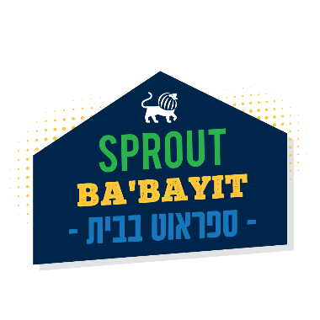

Sprout Lake Babayit
Ceramics Elective Week 1 – Grades 2-5
June 29th – July 3rd, 2020

- AIR DRY CLAY (2)
https://www.amazon.com/s?k=clay+air+dry&crid=XCRDK41MY4MC&sprefix=clay+ai%2Caps%2C293&ref=nb_sb_ss_i_1_7

- Pottery-Tool
https://www.amazon.com/SE-4PT8-Pottery-Tool-Set/dp/B0006VWRMW/ref=sr_1_5?dchild=1&keywords=Pottery+Tools+Clay&qid=1591685634&sr=8-5
- LACE FABRIC 16x16, or kind of left overs sizes
https://www.joann.com/search?q=FABRIC+lace

- Rolling pin :
https://www.amazon.com/s?k=Wooden+rolling+pin&ref=nb_sb_noss
- Plastic bowl:

https://www.amazon.com/s?k=Plastic+bowl&ref=nb_sb_noss_2

- CARDBOARD - Save your amazon packaging!

- 1 Bowl with water
- 1Old bed sheet to work on (we will be a bit messy ).

- 1 paper/notebook
- 1 pen/pencil
- 1 Scissors

- Hemp- 1 SPOOL
https://www.amazon.com/Hemp-Cord-Spool-Feet-Pkg-Natural/dp/B00642SSQG/ref=sr_1_6?crid=K7NKLUK6SERX&dchild=1&keywords=thread+for+macrame&qid=1591823904&sprefix=thread+for+ma%2Caps%2C295&sr=8-6

- Favorite object (figurine, doll, cards / anything that can inspire)
- acrylic paint
https://www.amazon.com/s?k=acrylic+paint&ref=nb_sb_noss

- If you have old nail polish
https://www.amazon.com/s?k=Nail+polish&ref=nb_sb_noss_2

- Newspapers (to keep our area clen when we pain)
- brushes.
https://www.amazon.com/pinceles-acr%C3%ADlica-acuarela-detalles-miniatura/dp/B07YDDF26Y/ref=sxin_7_ac_d_rm?ac_md=0-0-YnJ1c2hlcw%3D%3D-ac_d_rm&cv_ct_cx=Brushes&dchild=1&keywords=Brushes&pd_rd_i=B07YDDF26Y&pd_rd_r=212553ca-d4c7-47f4-8ee1-ec51f3a66c94&pd_rd_w=Fo4P9&pd_rd_wg=5selm&pf_rd_p=a0516f22-66df-4efd-8b9a-279a864d1512&pf_rd_r=MMNTEYAW5709K745FCZ5&psc=1&qid=1591823263&sr=1-1-12d4272d-8adb-4121-8624-135149aa9081

- Clear/white school glue- 4 oz (not a glue stick) -
- https://www.amazon.com/s?k=school+glue&i=office-products&ref=nb_sb_noss

