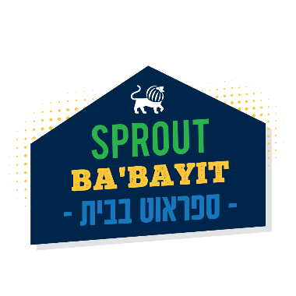

Sprout Lake Babayit
Water Color Desserts Elective
July 20th-24th, 2020

watercolor set

Brushes If you have brushes at home its fine

watercolor paper

